WILLIAMS, TENNESSEE (1911-1983)

At the height of his powers, in the 1940s and ’50s, Tennessee Williams not only courted the commercial success afforded by Broadway, but also sought to develop his own modernist aesthetic: an approach to all aspects of dramatic staging that sought to capture the truth of experience more faithfully than naturalism alone. He termed this his ‘plastic theatre’, embodying as it did the creative malleability normally afforded art and architecture.

Born in Columbus, Mississippi, Thomas Lanier Williams attended the University of Missouri and Washington University in St. Louis before being forced to work briefly in the shoe factory where his father had become a manager during the Depression. This humbling experience helped to shape a social vision—championing the individual against the might of capitalist oppression—and intensify the romantic appeal of the bohemian artist. In part, it was this appeal that prompted Williams to adopt the name ‘Tennessee’ in 1938.

His early plays—Candles to the Sun (1937), Fugitive Kind (1938), Not About Nightingales (1938), and Stairs to the Roof (1941)—developed Williams’ agenda in the tradition of the political theatre popular in the 1930s, especially the agitprop drama of Clifford Odets and the expressionist works of Elmer Rice. Apprentice pieces, these plays were mainly performed by an amateur company in St. Louis called The Mummers, under the direction of Willard Holland.

After the failure of tryout performances and subsequent rewrites of Williams’ first commercial venture, Battle of Angels (1940), the playwright worked on The Glass Menagerie (1944), a resounding success, particularly when it transferred from Chicago to Broadway. Though the social background to the play is alluded to in the narrator Tom Wingfield’s opening speech, Williams had by now chosen to mine more personal dramatic material: his family. The character of Laura Wingfield would prove to be the first of many representations of Williams’ sister Rose, and her shyness and vulnerability dictate the quietness of this memory play.

Williams’ comprehensive production notes for The Glass Menagerie suggest the influence of Brechtian modernism, gained through seminars given at the Dramatic Workshop of the New School for Social Research, under the directorship of Erwin Piscator, and silent films. Magic-lantern slides—dispensed with by many productions—are intended to project images and titles onto screens to clarify the writing and the episodic plot. Both lighting and music, tailored to each character and freighted with meaning, add to the sculptural effect or plasticity of the play, combining realism and expressionism.

Williams followed up the success of The Glass Menagerie with A Streetcar Named Desire (1947), a play that continued his method of mixing realism and expressionism. Set in New Orleans, a city that increasingly became Williams’ spiritual home following his first visit there at the end of 1938, Streetcar charts the decline of Blanche DuBois, a faded southern belle who comes up against the Lawrentian antagonist Stanley Kowalski, memorably played by a young Marlon Brando in both the Broadway premiere and the film adaptation of 1951. Williams’ descriptions of the set evoke the French Quarter’s lyricism, and a medley of sounds—‘blue’ piano music, the Varsouviana polka tune, jungle cries, and an approaching locomotive—captures mood and reflects Blanche’s nervousness as she continues to be haunted by the memory of her husband’s suicide and is mentally and emotionally destroyed by Stanley.

The success of Streetcar (855 performances on Broadway) would not be repeated, though Cat on a Hot Tin Roof (1955) earned the playwright a second Pulitzer Prize. In between, Williams’ career stalled with Camino Real (1953). Coming at the very end of the modernist era, this play exhibits several characteristics of the movement’s writing: gratuitous violence and an uncharted wasteland; characters drawn from history, literature, and myth; and no obvious central plot, only episodic scenes or ‘blocks’. Audiences were baffled by its surrealism and its veiled attack on McCarthyism.

Williams’ symbolism, evident in Camino Real and the plays before it, would also be a feature of his writing in the 1950s as he explored key themes like mendacity, lost youth, violence, and homosexuality and continued to create his ‘fugitive kind’—bruised individuals fleeing conformity and injustice. In 1957, while writing Suddenly Last Summer and after rewriting Battle of Angels as Orpheus Descending, Williams underwent psychoanalysis to alleviate clinical depression. This condition would deteriorate in the 1960s, however, a period that Williams called his ‘stoned age’, fuelled as it was by a cocktail of prescription drugs and alcohol. The Night of the Iguana (1961) marked his last Broadway success.

The plays that followed, forming the last phase of his career and commencing with The Milk Train Doesn’t Stop Here Anymore (1963), heralded a new experimentalism. Williams incorporated elements of Japanese Nō theatre in Milk Train and seems to have been influenced by both the Theatre of Cruelty and the Theatre of the Absurd in one-acts like The Gnädiges Fräulein (1966) and The Remarkable Rooming-House of Mme. Le Monde (1982), with their mix of slapstick and extreme violence. Elsewhere, postmodern features include: fractured, incomplete dialogue in The Bar of a Tokyo Hotel (1969); the metatheatre of Out Cry (1971); and the manipulation of memory through a double time frame in Vieux Carré (1977) and Something Cloudy, Something Clear (1981). Increasingly performed off-Broadway, the late plays were largely dismissed by critics at the time but have since been reappraised by scholars.

List of Works

Williams, Tennessee. (1971-1992) The Theatre of Tennessee Williams, 8 vols., New York: New Directions.

------ (1998) Not About Nightingales, ed. Allean Hale, New York: New Directions.

------ (2000) Stairs to the Roof, ed. Allean Hale, New York: New Directions.

------ (2001) Fugitive Kind, ed. Allean Hale, New York: New Directions.

------ (2004) Candles to the Sun, ed. Dan Isaac, New York: New Directions.

References and Further Reading
Bigsby, C. W. E. (2000) Modern American Drama, 1945-2000, Cambridge: Cambridge University Press.
Corrigan, Mary Ann. (1977) ‘Beyond Verisimilitude: Echoes of Expressionism in Williams’ Plays’, in Tennessee Williams: A Tribute, ed. Jac Tharpe, Jackson: University Press of Mississippi.
Hooper, Michael S. D. (2012) Sexual Politics in the Work of Tennessee Williams: Desire Over Protest, Cambridge: Cambridge University Press.
Kolin, Philip C. (2000) A Streetcar Named Desire, Cambridge: Cambridge University Press.
Leverich, Lyle. (1995) Tom: The Unknown Tennessee Williams, New York: W.W. Norton.

Murphy, Brenda. (2014) The Theatre of Tennessee Williams, London: Bloomsbury.

Savran, David. (1992) Communists, Cowboys, and Queers: The Politics of Masculinity in the Works of Arthur Miller and Tennessee Williams, Minneapolis: University of Minnesota Press.

Michael S. D. Hooper, St Margaret’s School

Recommended Illustrations

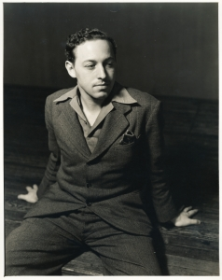

Tennessee Williams
[Billy Rose Theatre Collection, New York Public Library. Available at: http://digitalgallery.nypl.org/nypldigital/id?ps_the_cd100_1532]

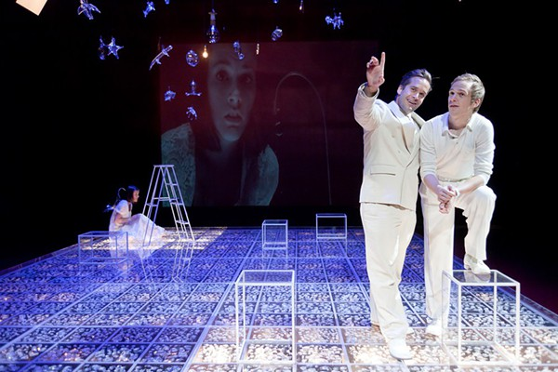

Cheryl Koski, Tyler Hollinger, and Matthew Carlson in an experimental production of The Glass Menagerie at Triad Stage in Greensboro, North Carolina in 2010.
[Available at: http://www.indyweek.com/indyweek/ImageArchives?oid=1694013&by=1689357]

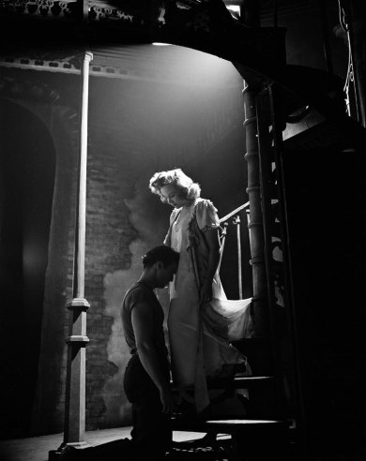

Marlon Brando and Kim Hunter in the Broadway premiere of A Streetcar Named Desire in 1947.
[Available at: http://life.time.com/culture/marlon-brando-in-a-streetcar-named-desire-photos-from-broadway-1947/#3]

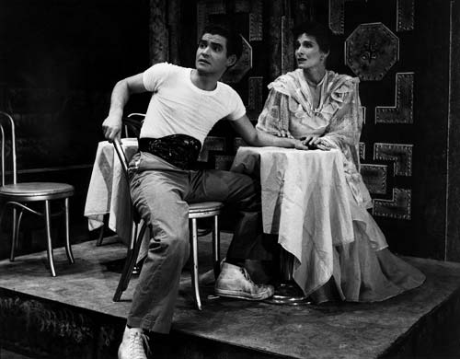

Jules Irving and Beatrice Manley in a 1954 production of Camino Real at the San Francisco Actor’s Workshop.
[Available at: http://www.beatricemanley.com/photogallery_camino.html]

